

AMERICAN INTERNATIONAL UNIVERSITY–BANGLADESH (AIUB)
Dept. of Computer Science
Faculty of Science and Technology
CSC2210: OBJECT ORIENTED PROGRAMMING 2
Spring 2023-2024
Section: [H]
Group No: 1312

Project Report On
Project Name [Super Shop Management System]
Supervised By
Md. Hasibul Hasan

Submitted By:
Name | ID
1. Bishal Paul | 22-47036-1
Obtained Marks for CO2 and CO3 (Description given in the following page)
Assessment  Criteria | Not Attended/ Incorrect (0) |  | Inadequate  (1-2) |  | Average  (3) | Good  (4) | Excellent  (5)
Evaluation Criteria (CO2) |  | Total = |  | Evaluation Criteria (CO3) |  |  | Total =
Requirement fulfillment |  |  |  | Organization of the application
Validation |  |  |  | Representation and Integration of Database
Verification |  |  |  | Graphical User Interface

CO2: Display and verify the mean of a real-life Project using the concepts of C# Graphical User Interface based environment with database integration to depict a desktop-based application.
Assessment  Criteria | Not Attended/ Incorrect (0) | Inadequate  (1-2) |  | Average  (3) |  | Good  (4) |  | Excellent  (5)
Evaluation Criteria | Evaluation Definition
Requirement fulfillment | Fails to demonstrate any understanding of real-life scenario-based project development or functional requirement identification. There is no attempt to depict a project or identify functional requirements accurately. |  | Demonstrates limited understanding of real-life scenario-based project development and functional requirement identification. The project depicted lacks coherence or relevance to real-life scenarios, and functional requirements are inaccurately identified or insufficiently described. |  | Presents a basic depiction of a real-life scenario-based project and identifies some functional requirements. However, the project lacks depth or complexity, and some functional requirements may be vaguely defined or missing key details. |  | Effectively demonstrates a realistic scenario-based project and accurately identifies most functional requirements. The project is well-developed with appropriate complexity, and functional requirements are clearly articulated with relevant details. |  | Exhibits an exceptional understanding of real-life scenario-based project development and accurately identifies all functional requirements. The project is meticulously developed with thorough attention to detail, reflecting a comprehensive understanding of Object-Oriented Programming project development activities.
Validation | Fails to demonstrate any understanding or implementation of validation forms in their system. There is no attempt to deal with data validation, and validation requirements are completely ignored or incorrectly applied. |  | Demonstrates limited understanding of validation forms and data validation techniques. While some attempt may be made to implement validation, it is incomplete or poorly executed, leading to inadequate handling of data validation. |  | Shows a basic understanding of validation forms and data validation techniques. They attempt to implement validation, but some aspects may be missing or incorrectly implemented, resulting in partial or inconsistent handling of data validation. |  | Effectively demonstrates the use of validation forms and implements data validation techniques. Validation is mostly accurate and comprehensive, ensuring the proper handling of data input and verification in the system. |  | Exhibits an exceptional understanding and implementation of validation forms and data validation techniques. Validation is meticulously implemented with thorough attention to detail, ensuring robust data validation procedures and contributing to the overall reliability and integrity of the system.
Verification | Fails to demonstrate any attempt to verify the system data or functional requirements. There is no evidence of understanding or implementation of verification processes, and data flow is not considered. |  | Demonstrates limited understanding of verification processes and data flow in the system. Verification attempts are incomplete or inaccurate, and there is insufficient consideration given to ensuring data integrity and functionality. |  | Shows a basic understanding of verification processes and attempts to verify system data. However, verification efforts may be inconsistent or lack thoroughness, and there may be gaps in ensuring proper functional requirements and data flow. |  | Identifies and verifies system data, ensuring proper functional requirements are met. Verification efforts are mostly accurate and thorough, with attention to ensuring data integrity and appropriate data flow within the system. |  | Exhibits an exceptional understanding of verification processes and meticulously verifies system data. Verification efforts are comprehensive and precise, with a keen focus on ensuring all functional requirements are met and maintaining proper data flow throughout the system.

CO3: Prepare and Explain a real life desktop based application synthesizing several component of C# along with development tools to adhere the given requirements.
Assessment  Criteria | Not Attended/ Incorrect (0) | Inadequate  (1-2) |  | Average  (3) |  | Good  (4) |  | Excellent  (5)
Evaluation Criteria | Evaluation Definition
Organization of the application | Fails to identify any suitable real time application or requirements for project development activities related to OOP. |  | Limited understanding about the project scopes and scenarios or identification of functional requirements. |  | Lacks depth or relevance to OOP project development activities and may contain inaccuracies. Real-life scenarios are mentioned, but the discussion lacks depth or clarity. |  | Consider and integrate the idea of several core aspects of the project along with relevance to real-life scenarios. Demonstrating a solid understanding of the application presentation. |  | Generalize and exhibits an exceptional understanding of project preparation according to a to real-life scenarios. Also contains proper and insightful identification of the system which is comprehensive and precise.
Representation and Integration of Database | Fails to identify and present any understanding or implementation of database. Also failed to integrate the data with the project itself. |  | Limited understanding of the database concepts or their proper way of using in a real time project. While some attempt may be made to implement but it is incomplete or poorly executed, leading to inadequate design. |  | Lacks depth or relevance to database integration with the application. Shows a basic understanding but some aspects may be missing or incorrectly implemented, resulting in partial or inconsistency. May lack proper normalization. |  | Integrate the database with the forms properly and implements it with proper validation which is mostly accurate and comprehensive, ensuring the proper handling of data input and verification along with general normalization. |  | Exhibits an exceptional understanding and implementation of database ensuring attention to detail, and robust data manipulation procedures and contributing to the overall clarity.
Graphical User Interface | Fails to present or prepare GUI based application interfaces. There is no evidence of creating or integrating such things according to their usefulness. |  | Limited understanding of graphical user interfaces. Lack of design knowledge. Very poor attempt to make such things which are currently obsolete or can’t be identified as coherent. |  | Shows a basic understanding of creating user interfaces. Most of them are interconnected but maybe some of them lack it. However, most of it can be described as user friendly. |  | Effectively identifies and meet the consider the simplicity. Design related works are mostly accurate and taken proper attention to ensuring a user-friendly coherent system. |  | Exhibits an exceptional work design following a high standard of simple and elegant work. Several controls and mechanism has been organized in a preferred way according to the coherent usage .

Table of Contents:
Page no.
1. Chapter :01 (Introduction)----------------------------------------------------03
2. Chapter :02(User Story)-------------------------------------------------------03
3. Chapter :03 (ER Diagram)----------------------------------------------------05
4. Chapter :03 (SQL Queries)---------------------------------------------------06
5. Chapter:04 (Screenshots) -----------------------------------------------------09

1.Introduction :

In a comprehensive super shop management system, two distinct user roles exist: the manager and the employee. The manager holds authority to update their profile information, along with the ability to modify the profiles of any manager or employee within the system, excluding sensitive user credentials like usernames and passwords. Furthermore, the manager is empowered to add or remove both managers and employees as required, thereby facilitating efficient workforce management. Additionally, the manager possesses the capability to access and review sales records to monitor business performance effectively. Moreover, the manager is entrusted with the responsibility to manage the shop's inventory by adding or removing products and employees as deemed necessary to maintain operational efficiency. On the other hand, the employee role allows for personal profile updates and the crucial function of generating transaction bills, ensuring seamless customer service delivery within the establishment. This delineation of roles between manager and employee establishes a structured and efficient operational framework within the super shop management system.

User Story: As a Manager, Employee.

Manager Perspective:
Manager can update his profile. manager can also update any manager or employee profile except user name and password. manager can add or remove any manager or employee. manager can also see the sells record. manager can also add and remove product.
Employee Perspective:
Employee can update his profile. Employee can add or remove any product. An Employee can Also make transaction bills for customer.

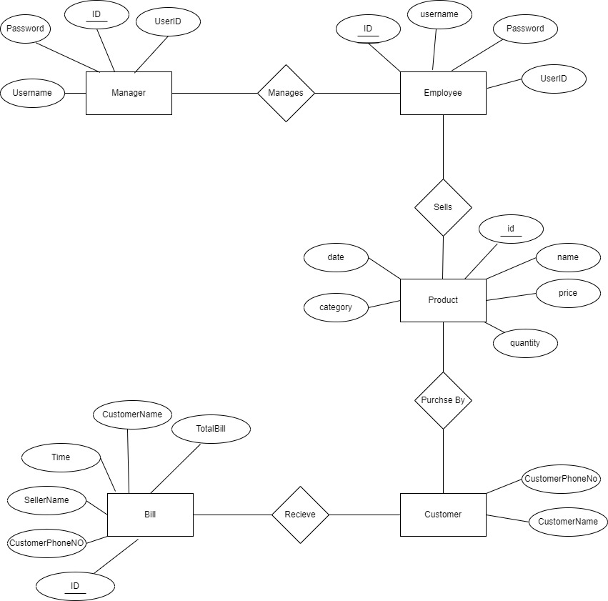

Manages:
UNF: ID, UserID, Password, ID, UserID, Password
1NF: ID, UserID, Password, ID, UserID, Password
2NF: ID, UserID, Password, ID, UserID, Password

Sells:
UNF :ID,UserID, category,id,date,name,price
1NF: ID, UserID, category , id ,date, price
2NF: 1st:ID, UserID, category , price
2nd : id ,date ,name

Purchase :
UNF: ID, name, price , category ,date ,CustomerName, PhoneNO
1NF: Id ,name , price , category , date , CustomerName , PhoneNO
2NF: 1st : Id, Name , Price
2nd : Id, name , category , date
3rd : Id, name, CustomerName , PhoneNo
Receive :
UNF: CustomerName, CustomerNo , ID, Time ,SellerName , Time , TotalBill
1NF: CustomerName, CustomerPhoneNo, ID, Time, SellerName, TotalBill
2NF: 1st : CustomerName, CustomerPhoneNo,ID, SellerName, Time
2nd : CustomerName,CustomerPhoneNo, TotalBill

SQL Queries:

USE [Supershop]
GO
/****** Object: Table [dbo].[InfoTable] Script Date: 5/14/2024 5:01:08 AM ******/
SET ANSI_NULLS ON
GO
SET QUOTED_IDENTIFIER ON
GO
CREATE TABLE [dbo].[InfoTable](
[id] [int] NOT NULL,
[UserID] [nvarchar](20) NOT NULL,
[Name] [nvarchar](20) NOT NULL,
[Email] [nvarchar](30) NULL,
[Phone] [int] NOT NULL,
[Role] [nvarchar](10) NOT NULL,
[Date Of Birth] [date] NULL,
CONSTRAINT [PK_InfoTable] PRIMARY KEY CLUSTERED
(
[id] ASC
)WITH (PAD_INDEX = OFF, STATISTICS_NORECOMPUTE = OFF, IGNORE_DUP_KEY = OFF, ALLOW_ROW_LOCKS = ON, ALLOW_PAGE_LOCKS = ON) ON [PRIMARY]
) ON [PRIMARY]

GO
/****** Object: Table [dbo].[LoginTable] Script Date: 5/14/2024 5:01:08 AM ******/
SET ANSI_NULLS ON
GO
SET QUOTED_IDENTIFIER ON
GO
SET ANSI_PADDING ON
GO
CREATE TABLE [dbo].[LoginTable](
[ID] [int] IDENTITY(101,1) NOT NULL,
[Username] [varchar](30) NULL,
[Password] [varchar](20) NULL,
[UserId] [int] NULL,
CONSTRAINT [PK_LoginTable] PRIMARY KEY CLUSTERED
(
[ID] ASC
)WITH (PAD_INDEX = OFF, STATISTICS_NORECOMPUTE = OFF, IGNORE_DUP_KEY = OFF, ALLOW_ROW_LOCKS = ON, ALLOW_PAGE_LOCKS = ON) ON [PRIMARY]
) ON [PRIMARY]

GO
SET ANSI_PADDING OFF
GO
/****** Object: Table [dbo].[ProductTable] Script Date: 5/14/2024 5:01:08 AM ******/
SET ANSI_NULLS ON
GO
SET QUOTED_IDENTIFIER ON
GO
CREATE TABLE [dbo].[ProductTable](
[id] [nvarchar](20) NOT NULL,
[name] [nvarchar](30) NOT NULL,
[price] [float] NOT NULL,
[quantity] [int] NOT NULL,
[date] [datetime] NOT NULL,
[category] [nvarchar](50) NOT NULL
) ON [PRIMARY]

GO
/****** Object: Table [dbo].[RecordTable] Script Date: 5/14/2024 5:01:08 AM ******/
SET ANSI_NULLS ON
GO
SET QUOTED_IDENTIFIER ON
GO
CREATE TABLE [dbo].[RecordTable](
[Bill_ID] [int] IDENTITY(1,1) NOT NULL,
[CustomerName] [nvarchar](30) NOT NULL,
[CustomerPhoneNo] [int] NOT NULL,
[SellerName] [nvarchar](20) NOT NULL,
[Time] [datetime] NOT NULL,
[TotalBill] [float] NULL,
CONSTRAINT [PK_Record] PRIMARY KEY CLUSTERED
(
[Bill_ID] ASC
)WITH (PAD_INDEX = OFF, STATISTICS_NORECOMPUTE = OFF, IGNORE_DUP_KEY = OFF, ALLOW_ROW_LOCKS = ON, ALLOW_PAGE_LOCKS = ON) ON [PRIMARY]
) ON [PRIMARY]

GO
INSERT [dbo].[InfoTable] ([id], [UserID], [Name], [Email], [Phone], [Role], [Date Of Birth]) VALUES (1, N'e-101', N'sifat', N'sifat@gmail.com', 9654, N'employee', CAST(N'2001-05-15' AS Date))
INSERT [dbo].[InfoTable] ([id], [UserID], [Name], [Email], [Phone], [Role], [Date Of Birth]) VALUES (2, N'm-101', N'bishal pal', N'bishal12@gmail.com', 54541564, N'manager', CAST(N'2001-01-05' AS Date))
INSERT [dbo].[InfoTable] ([id], [UserID], [Name], [Email], [Phone], [Role], [Date Of Birth]) VALUES (3, N'm-102', N'jadid', N'jadid@gmail.com', 7884, N'manager', CAST(N'2001-10-09' AS Date))
INSERT [dbo].[InfoTable] ([id], [UserID], [Name], [Email], [Phone], [Role], [Date Of Birth]) VALUES (4, N'e-102', N'maria', N'maria@gmail.com', 5454, N'employee', CAST(N'2003-06-12' AS Date))
INSERT [dbo].[InfoTable] ([id], [UserID], [Name], [Email], [Phone], [Role], [Date Of Birth]) VALUES (5, N'e-103', N'tony', N'tony@gmail.com', 3000, N'employee', CAST(N'1980-12-30' AS Date))
SET IDENTITY_INSERT [dbo].[LoginTable] ON

INSERT [dbo].[LoginTable] ([ID], [Username], [Password], [UserId]) VALUES (101, N'bishal101', N'1234', 2)
INSERT [dbo].[LoginTable] ([ID], [Username], [Password], [UserId]) VALUES (102, N'sifat201', N'123', 1)
INSERT [dbo].[LoginTable] ([ID], [Username], [Password], [UserId]) VALUES (103, N'jadid102', N'123', 3)
INSERT [dbo].[LoginTable] ([ID], [Username], [Password], [UserId]) VALUES (104, N'maria202', N'123', 4)
INSERT [dbo].[LoginTable] ([ID], [Username], [Password], [UserId]) VALUES (119, N'tony3000', N'300', 5)
SET IDENTITY_INSERT [dbo].[LoginTable] OFF
INSERT [dbo].[ProductTable] ([id], [name], [price], [quantity], [date], [category]) VALUES (N'p-101', N'detos', 20, 0, CAST(N'2024-04-05 08:36:12.000' AS DateTime), N'snacks')
INSERT [dbo].[ProductTable] ([id], [name], [price], [quantity], [date], [category]) VALUES (N'p-102', N'sprite', 25, 30, CAST(N'2024-03-12 09:25:36.000' AS DateTime), N'soft drinks')
INSERT [dbo].[ProductTable] ([id], [name], [price], [quantity], [date], [category]) VALUES (N'p-103', N'onion', 60, 42, CAST(N'2024-05-12 14:52:20.000' AS DateTime), N'grocery')
INSERT [dbo].[ProductTable] ([id], [name], [price], [quantity], [date], [category]) VALUES (N'p-104', N'fish', 500, 24, CAST(N'2024-05-13 14:58:05.000' AS DateTime), N'meat & fish')
SET IDENTITY_INSERT [dbo].[RecordTable] ON

INSERT [dbo].[RecordTable] ([Bill_ID], [CustomerName], [CustomerPhoneNo], [SellerName], [Time], [TotalBill]) VALUES (21, N'soumik', 7895, N'sifat201', CAST(N'2024-05-14 04:28:01.000' AS DateTime), 180)
SET IDENTITY_INSERT [dbo].[RecordTable] OFF
ALTER TABLE [dbo].[LoginTable] WITH CHECK ADD CONSTRAINT [FK_LoginTable_InfoTable] FOREIGN KEY([UserId])
REFERENCES [dbo].[InfoTable] ([id])
GO
ALTER TABLE [dbo].[LoginTable] CHECK CONSTRAINT [FK_LoginTable_InfoTable]
GO

Screenshots:
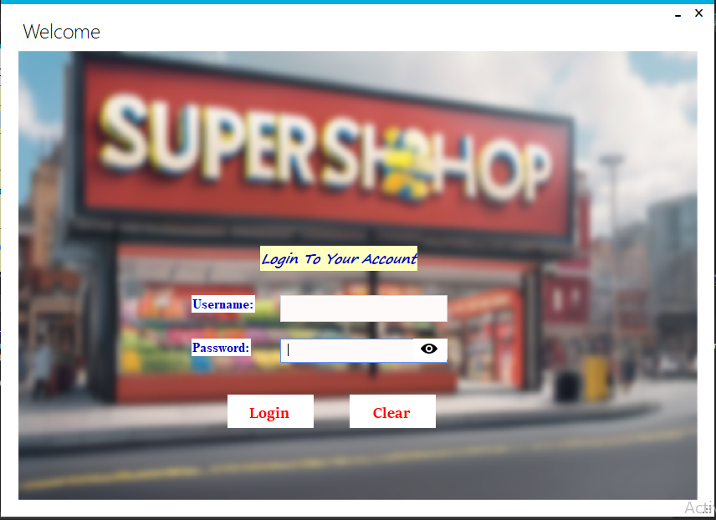

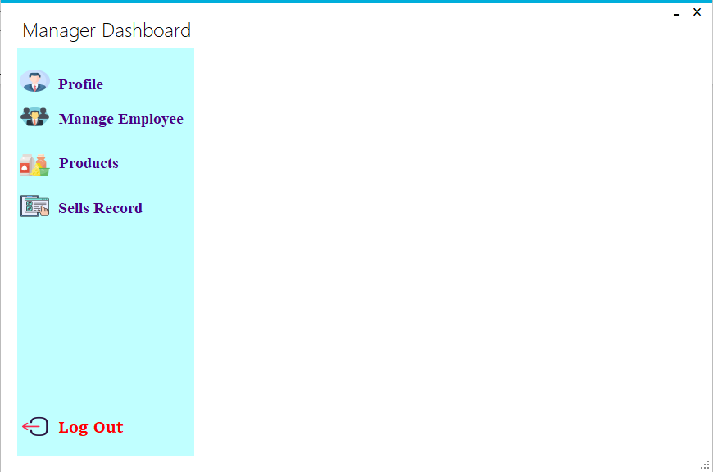

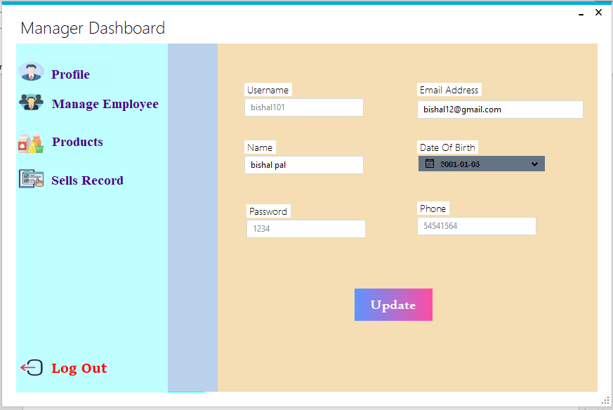

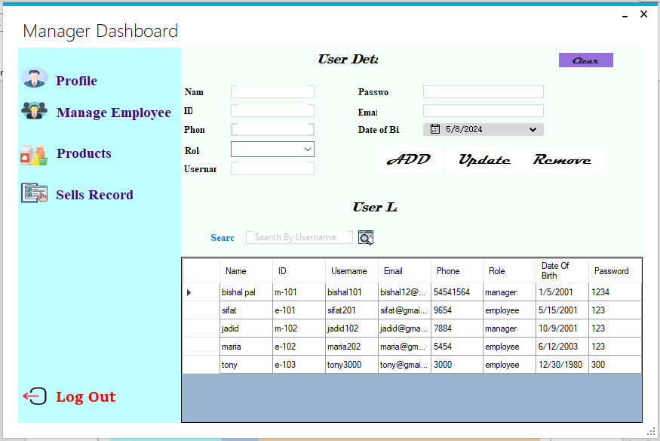

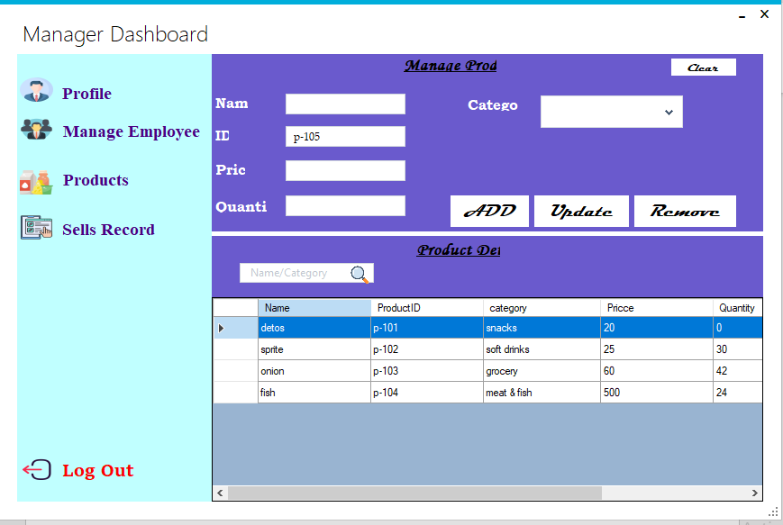

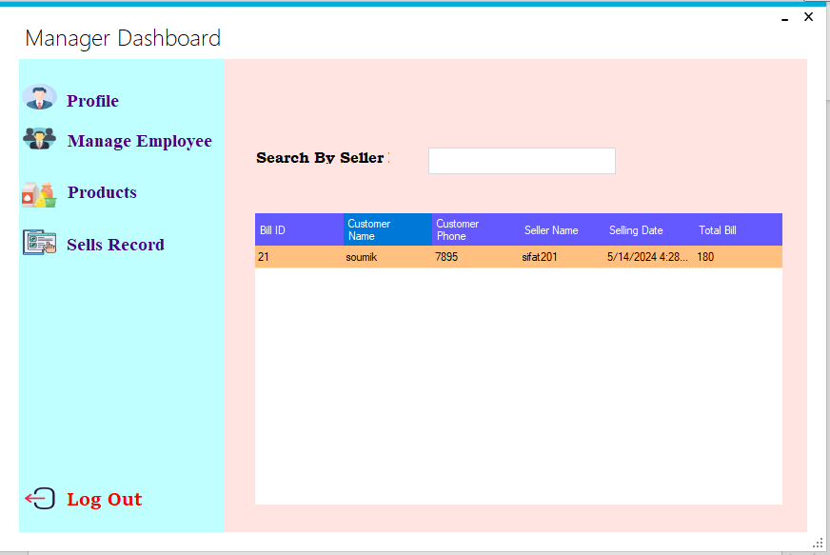

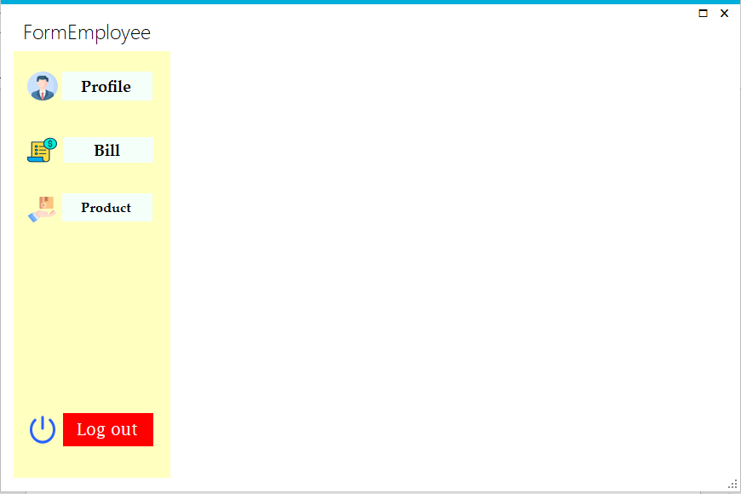

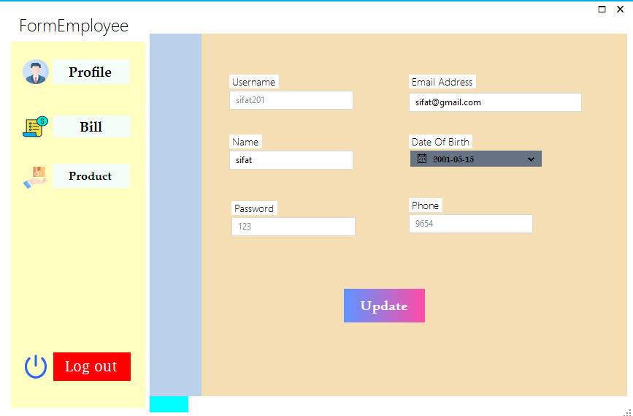

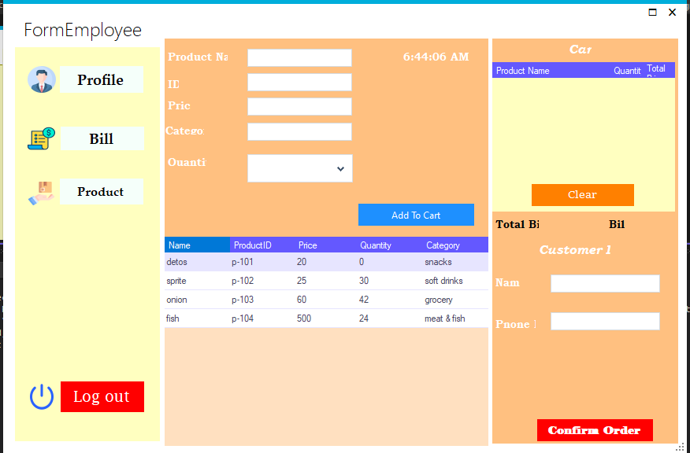

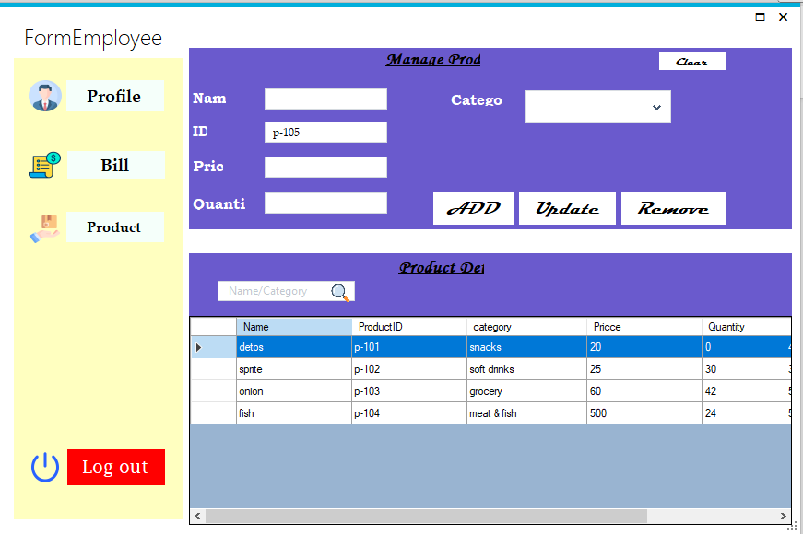

Conclusion: In summary, our objective is to show a supershop management system by a desktop based application. We have tried to show some real life aspect through this project by implementing our knowledge on windows form application. It also shows the outcome of our knowledge. Overall this project will give a slight overview to the customers how a supershop runs.

Reference:
MD. HASIBUL HASAN
hasib.hasan@aiub.edu
American International University-Bangladesh(AIUB) .

